**Database System Lab Task**

**Name Basharat Hussain**

**Roll No: P17-6102**

**DB LAB Task: 11**

**Instructor: Muhammad Usman.**

**Question**

* **Create a database named your rollno_section (i.e. 19P0084_4A).**

**> db.dropDatabase();**

**> use 17P6102_6B;**

**> show dbs;**

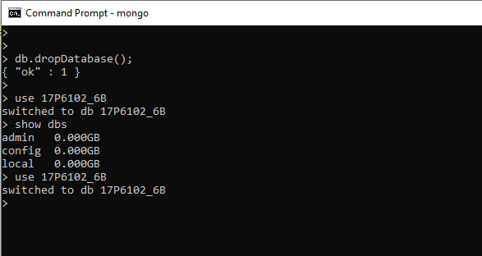

* **Create a collection named users.**

**> db.createCollection("users");**

**> show collections;**

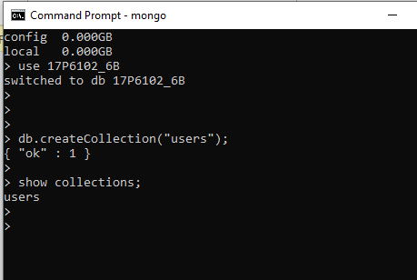

* **Insert the following record in the user’s collection.**

**> db.users.insertMany([**

**... {username:"abc123", password:"def321", email:"abc123@yahoo.com", DOB:" ", Address:"Peshawar", Contact:"+923332233322"},**

**... {username:"xyz789", password:"vbn123", email:"xyz789@gmail.com", DOB:" ", Address:"Karachi", Contact:" "},**

**... {username:"zain", password:"Abc123", email:"zain@gmail.com", DOB:"1997-02- 13", Address:"Islamabad", Contact:" "},**

**... {username:"Atif", password:"Qwe123", email:"atif@gmail.com", DOB:" ", Address:"Islamabad", Contact:" "}**

**... ])**

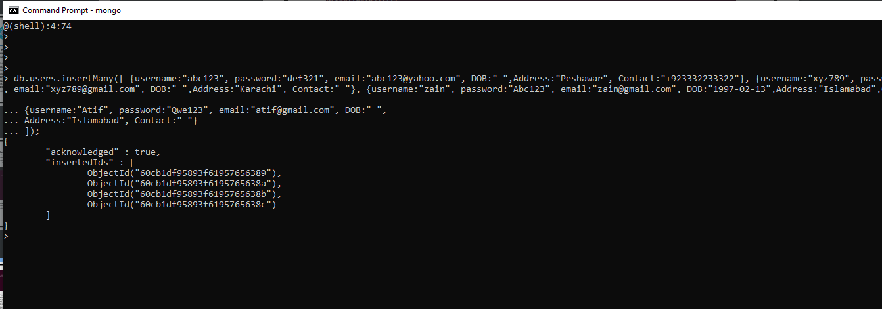

* **Show all users list using find command.**

**> db.users.find();**

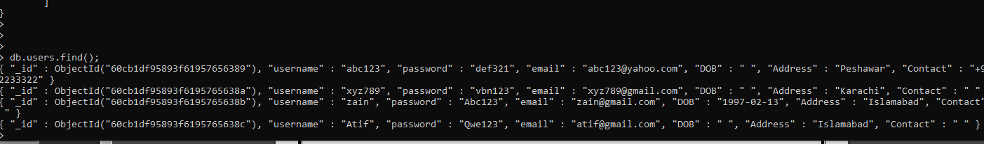

* **Show all users who lives in Islamabad.**

**> db.users.find({Address:"Islamabad"});**

